Outings and Events, May 2005
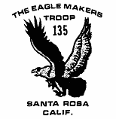
4/16-17 Mt. Tam
5/9* CPR Training
5/16* Safe Swim Training
5/16* Safety Afloat Training
5/17* Committee Meeting
6/6 Court of Honor
6/11-6/12* Canoe trip
7/17-23 Scout Camp
7/29-8/14 Yosemite Long Trip
8/6-8/14 Yosemite Short Trip
9/2-9/5* Trinity Alps Trip

* new date

April Outdoors: A hike was conducted over and around the local geological feature known affectionately as Mt. Tam, capably led by the ageless and energetic Phil Weil. There was a longer hike and a shorter hike. The regular or "normal" hike, the one that the longer hike was longer than and the shorter hike was shorter than, was dropped because none of the Scouts who participated were found to fit in the category "normal." For instance, three of the Scouts spent the longer hike discussing Star Wars or some such and were so engrossed that when they were asked their impressions of the hike they said, in essence, what hike? Marie Borell, however, hiked neither shorter nor longer nor normal, but went on a separate hike all by herself and on her own saw perfect weather, waterfalls, wildflowers, and lots of views. Perhaps it was easy for her to remember because she had no one to talk to except herself, and she hasn't seen Star Wars.

Fly Like an Eagle: Guess who had his Eagle board of review and passed it? That's correct, our very own Nick Ule. Congratulations to Troop 135's newest Eagle!

Survival tip: To collect drinkable water in the backcountry, simply place your boots outside your tent while it is raining and they will fill with water overnight all by themselves, no pumping required. Do not turn the boots upside down or place them under a waterproof covering, as this would cause them to stay dry. Also works for hail. Procedure was field tested by Anthony Holtz. We wouldn't give you a survival tip that hadn't been tested, now, would we?
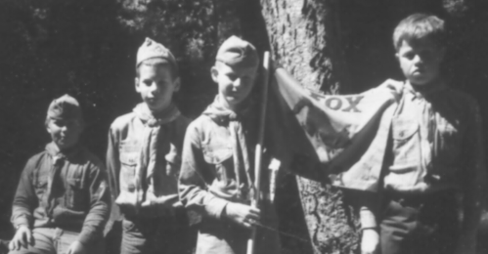
Missing: Several letters have gone missing in the last two months. They are of the lowercase "C" variety and through deceitful wiles escaped from Mr. Hauck's name. They were last observed running from the April newsletter and haven't been seen since. If you happen to run into them do not attempt contact, as they should be considered armed and dangerous. One is rumored to have taken up residence in the word vicious and several others were seen hanging around the words decapitate and contusion.

SPL News: Anthony Holtz is still in office. No reasonable explanation is forthcoming. Filling in as Senior Patrol Leader on temporary assignment for the April 4th meeting, Cyrus Cumming showed leadership potential by involving the troop in what came to be known as toilet paper streamer night. Due to environmental impact this event will not be held again anytime soon. Several trees gave their lives to create the toilet paper used for the game on this occasion.

Yosemite Backpack: The dates are set. Trip costs will be $100+food costs. To find the final cost before the food is actually purchased simply use Levenger's Laws of Food Mathematics. For those who are interested, the troop will be providing training in food math very soon. To figure out when the training will be given before it is actually offered simply apply Taylor's Laws of Training Schedule Probability. Schedule Probability Training will commence shortly. To determine when this course will be given simply take it and then apply Meyer's 20/20 Hindsight Principle. Speaking of scheduling, the long trip is being planned by Robbie and Anthony. Now that should be interesting. To discover just how interesting just wait four months or so and see who makes it back alive.

Adult training: If you need training as an adult, good luck. However, there is CPR on 5/9 and Swim Stuff on 5/16. 7:30 PM at the church. Be there or be somewhere else.

April Mystery Scout: The lucky guy in last month's newsletter was, of course, Loren McKezer, seen here grazing on his favorite bit-o-luck. Loren is a good guy to be around on a pack trip because, in addition to walking with his fingers crossed, he usually carries a horseshoe and a rabbit's foot in his pack.

And we have a winner: Yes, it is true. Someone guessed the April Mystery Scout from a small image of just one eye. It was, of course, Mrs. McKezer. Who else but a mother could recognize a young man from a photographic image of his eye no larger than the nostril of his friend's dog?

Mystery Scout of May: Someone you know is in the photo below. Or else someone you don't know is in the photo below. And it's the same guy. Which one and who is it?

Newsletter: Insider info by J Ryall
Additional reporting by B Cumming and M Borell
Editing by R Ryall. Rick.Ryall@CierraPhotonics.com

